Instructions for Manuscript Preparation (Font Times New Roman 12 pt Bold)
2nd Report: Subtitle if you need (Font times new roman 12 pt bold)
(a 12 pt line space)
+Taro REITO*, Hanako KUCHO** and Jiro SHOKUHIN*** (Font Times New Roman 10pt)
*Department of Mechanical Engineering, Nihonbashi University, Chuo-ku, Tokyo, 103-0011, Japan
**Department of Physics, Chuo Institute of Technology, Meguro-ku, Tokyo, 152-0033, Japan
***Department of Chemical Engineering, Otomi University, Shibuya-ku, Tokyo, 151-0053, Japan
(two lines space with 10 pt)

Abstract should be written with 10 pt Times New Roman and single-space from here. The length of the abstract is limited within 150 words. Please send a PDF(.pdf) file of 2 - 6 pages with A4 size to the scientific secretary jsrae22@jsrae.or.jp . High quality setting is recommended for PDF conversion. The file should be less than 5 MB. Deadline: July, 8th, Friday
．．．．．．．．．．．．．．．．．．．．．．．．．．．．．．．．．．．．．．．．．．．．．．．．．．．．．．．．．．．．．．．．．．．．(The end of abstract)．
(a 10 pt line space)
Keywords: Keyword1, Keyword2, Keyword3, Keyword4, Keyword5
(two lines space with 10 pt)

1. Introduction (Top heading should be in bold)
Manuscripts should be made from two to six pages of A4 paper. The main text should be written in single-column format with a font of 10 pt Times New Roman.

2. Paper size and Margins
2.1 Paper size
A4 Paper

2.2 Margins
top : 25 mm, bottom : 25 mm
left : 20 mm, right : 20 mm
upper header : 15 mm from top edge of paper

3. Format
Manuscripts should consist of the title, author(s), author’s affiliation and address, abstract, keywords, and main text. Title, author(s), author’s affiliation and address, abstract and keywords should be written according to the format given above.

3.1 Main text
Main text should begin two lines bellow keywords. If indentation is used, it must be five spaces for each indentation.

3.2 Heading
Examples of heading are as follows.
(a 10 pt line space)
4. Top Heading Sample
Experimental setup is shown in Fig.1. ....
(a 10 pt line space)
4.1 2nd heading sample
(1) 3rd heading sample
Thermocouples were inserted in capillary tubes ...
(a 10 pt line space)
5. Equations
Equations and symbols should be written with 10pt italic font except super/sub scripts. There should be one line space upper and lower equation. In the main text, an equation is explained as Eq.(1).
(a 10 pt line space)
(1)
(a 10 pt line space)
6. Figures, Tables, Pictures
Color figures are acceptable. Keep margins. Figures, tables, and photos should be explained in main text as Fig.1, Table 1, Photo 1. Examples are as follows.
(a 10 pt line space)
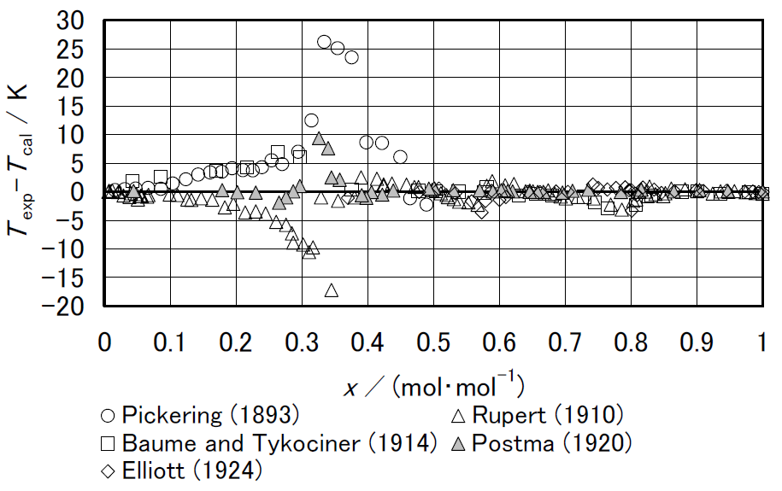
(a 10 pt line space)
Fig.1 Deviation of measured freezing point temperatures from correlations by Tillner-Roth [2].
(a 10 pt line space)
Table 1 Historical data of vapor pressure of ammonia.
(a 10 pt line space)
Author | Year | T | p | Ref.
Keyes | 1918 | 240-398 | 0.103-9.96 | 1
Cragoe | 1920 | 195-343 | 0.00563-3.31 | 25
McKelvey | 1923 | 195-195 | 0.1 | 26
Beattie | 1930 | 303-405 | 1.17-11.3 | 8
Overstreet | 1937 | 176-242 | 0.0008-0.1114 | 27
(a 10 pt line space)
7. References
References should be indicated by [1], [2, 3], [4-7], and be listed at the end of manuscript. Examples are shown in the next page.

8. How to Submit Your Manuscript
Please send your manuscript in PDF format to Scientific Secretary via E-mail as follows. High quality setting is recommended for PDF conversion. The file should be less than 5 MB.
The file name will be fixed automatically as "abstract submission number.pdf". The number has sent to you through an e-mail when you applied for presentation with your abstract and author's information.
E-mail: jsrae22@jsrae.or.jp

5. Deadline
July, 8th, 2022

6. Inquiry
Organizing Committee of 2022 JARAE Annual Conference
jsrae22@jsrae.or.jp
(a 10 pt line space)
NOMENCLATURE
c_{p} | : specific heat at constant pressure, kJ･kg⁻¹･K⁻¹
h | : specific enthalpy, kJ･kg⁻¹
p | : pressure, kPa
T | : temperature, K
t | : Celsius temperature, ℃
V | : volume, m³

REFERENCES
[1] F. G. Keyes and R.B. Brownlee, The Vapor Pressure of Liquid Ammonia up to the Critical Temperature. [Part II.], Journal of the American Chemical Society, 40(1) (1918), pp. 25–53.
[2] R. Tillner-Roth, J. Li, A. Yokozeki, H. Sato and K. Watanabe, “Thermodynamic Properties of Pure and Blended Hydrofluorocarbon (HFC) Refrigerants”, JSRAE, (1997).
[3] T. Miyazaki and K. Oguchi, Proc. 2001 JSRAE Annual Conference, JSRAE, (2001), pp. 181–184. (in Japanese)
Technical report of JSRAE, JSRAE Corp., (2010. 4).
[4] Wind in power: 2015 European statistics, available from <http://www.ewea.org/statistics/>, (accessed on Apr. 14, 2016).

